Place Your Title Here

M. Stoddart1, M. Alini1, RG.Richards1,2

1AO Research Institute, AO Foundation, Davos, CH, 2 Connective Tissue Biology Labs, School of Biosciences, Cardiff University, Wales, GB

**INTRODUCTION:** The proceedings will be published as abstracts' collection in eCM conferences Open Access online periodical & eCM annual conferences (http://www.ecmconferences.org/). The present Microsoft Word file must be used as a template for the abstract production. The easiest way to use this abstract form is by cutting and pasting of unformatted text, to maintain the present format.

**METHODS:** All abstracts must be fit within an A4 paper (210 x 297 mm). Margin sizes must not be altered and are set to 25 mm. The entire document is set to 2 columns with 10 mm of intercolumn spacing (column width of 75 mm). Paragraph is justified, with single line-spacing. Do not use fonts other than 11 pt Times New Roman and Symbol in the document (including equations and figures).

*Title* should be in bold. *Authors* should be listed consecutively by first name initial(s) and last name. Authors may be hyperlinked to their e-mail address. *Affiliation* should be indicated with superscipted suffix Arabic numerals. Do not append degrees, professional designations, *etc.* to names. Affiliations should be listed consecutively and may be hyperlinked to the related web page.

**RESULTS:** Figures should be inserted using the "Insert Figure" function and have the caption below them. Tables should be inserted using the "Insert Table" function and have the caption above them. Figure and table caption can use *Italics* or a smaller font, to make it distinguishable from the main text. Scanned figures should have a minimum resolution of 300 dpi for an 80 mm figure width. **JPEG is the preferred format.** Equations should be inserted using the "Insert Equation" function:

*k(t) =  exp(- tη)* ***1****(t)* (1)

and should be tab centred, with the number in parentheses on the right.

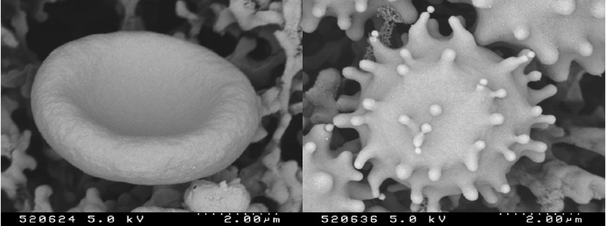

Fig. 1: Effect of stress on erythrocyte morphology: normal (happy) erythrocyte (left) vs. stressed (“bad hair day”) erythocyte (right).

Table 1. Relative allocation and amount of resources in research.

|  |  |  |
| --- | --- | --- |
|  | Amount of resources | Allocation freedom |
| Industry | high | constrained |
| Academic | low | unconstrained |

**DISCUSSION & CONCLUSIONS:** Please submit the abstract as a Word document for Windows. Only electronic submissions will be accepted and not in PDF format. The abstracts must not exceed 5MB in size! The abstracts may be submitted by e-mail (attachment) labelled with presenting author as the file name.

**ACKNOWLEDGEMENTS:** This template was modified with kind permission from eCM conferences Open Access online periodical & eCM annual conferences

**REFERENCES:** Upon need. References should be set as one block and a maximum of four references may be used.